- 1. CRUD-CREATE

- CREATE DATABASE shirts_db;

- USE shirts_db;

- CREATE TABLE shirts (
- shirt_id INT AUTO_INCREMENT PRIMARY KEY,
- article VARCHAR(50),
- color VARCHAR(50),
- shirt_size VARCHAR(5),
- last_worn INT
- );

- DESC shirts;

- INSERT INTO shirts (article, color, shirt_size, last_worn)
- VALUES
- ('t-shirt', 'white', 'S', 10),
- ('t-shirt', 'green', 'S', 200),
- ('polo shirt', 'black', 'M', 10),
- ('tank top', 'blue', 'S', 50),
- ('t-shirt', 'pink', 'S', 0),
- ('polo shirt', 'red', 'M', 5),
- ('tank top', 'white', 'S', 200),
- ('tank top', 'blue', 'M', 15);

- INSERT INTO shirts (article, color, shirt_size, last_worn)
- VALUES ('polo shirt','purple', 'M', 50);

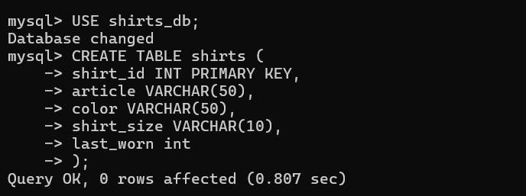

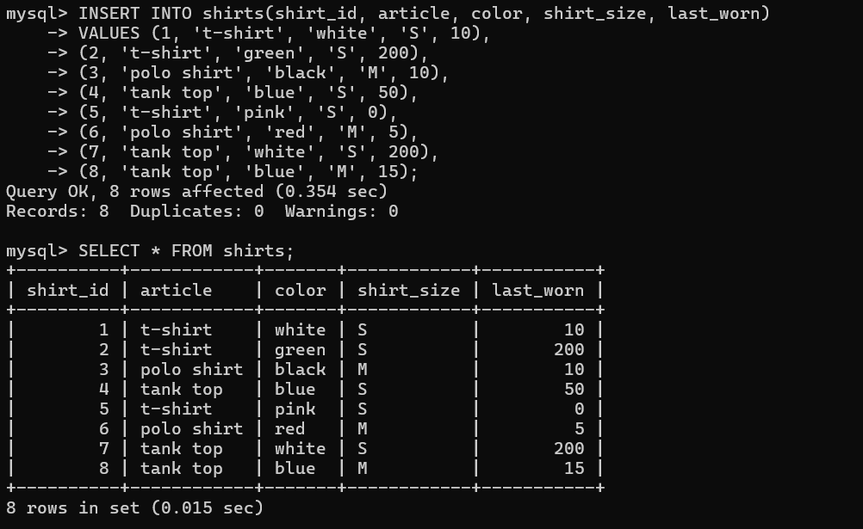

Add new values -> 9th one.
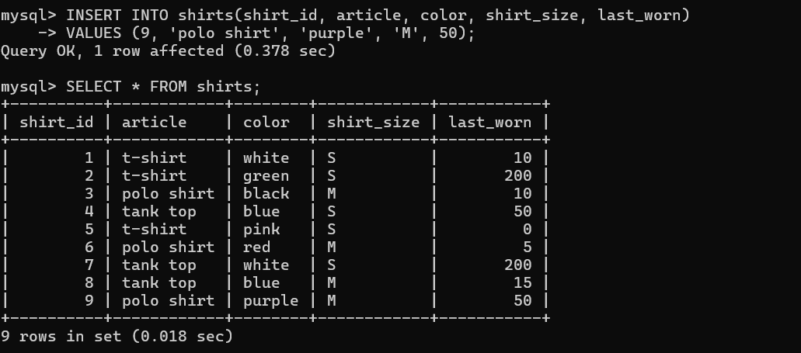

2.CRUD-READ

- SELECT article, color FROM shirts;

- SELECT * FROM shirts WHERE shirt_size='M';

- SELECT article, color, shirt_size, last_worn FROM shirts WHERE shirt_size='M';

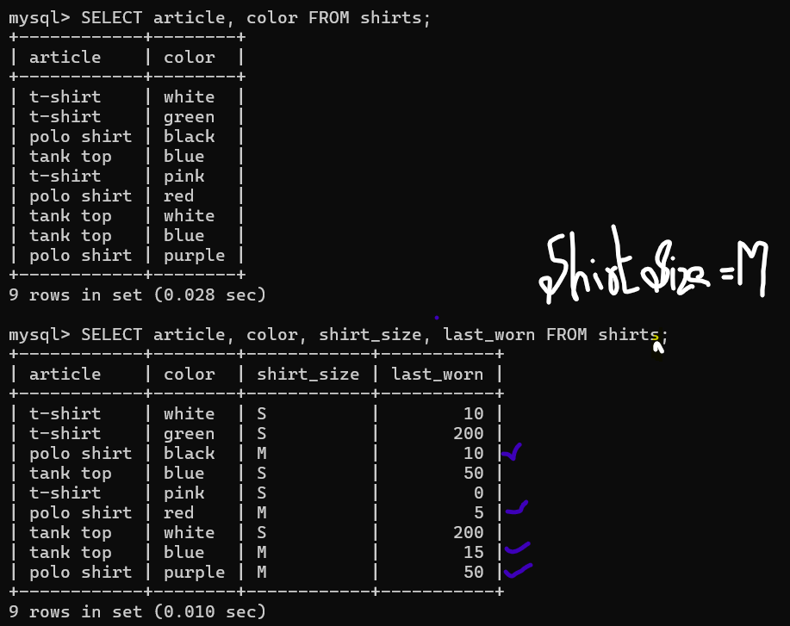

3. CRUD-UPDATE

- UPDATE shirts
- SET
- shirt_size = 'L'
- WHERE
- article = 'polo shirt';

- UPDATE shirts
- SET
- last_worn = 0
- WHERE
- last_worn = 15;

- UPDATE shirts
- SET
- color = 'off white',
- shirt_size = 'XS'
- WHERE
- color = 'white';

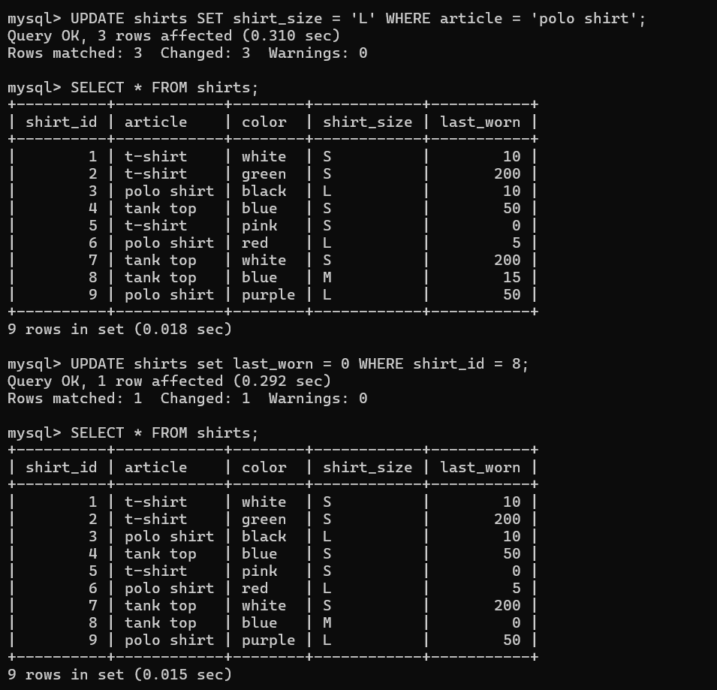

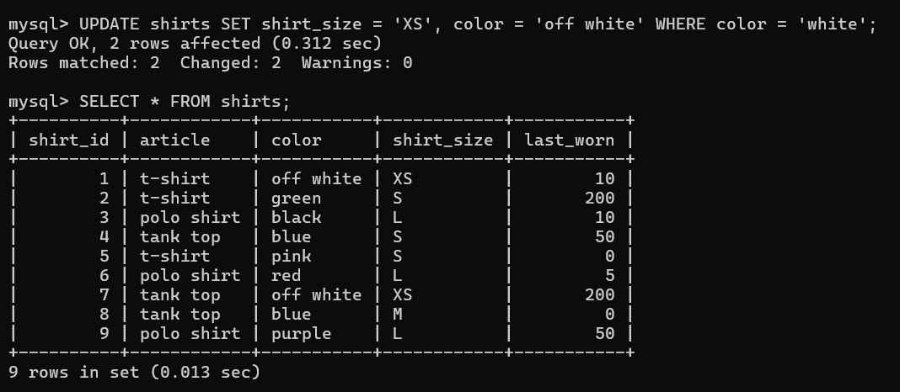

4.CRUD-DELETE

- SELECT * FROM shirts WHERE last_worn=200;

- DELETE FROM shirts WHERE last_worn=200;

- SELECT * FROM shirts WHERE article='tank top';

- DELETE FROM shirts WHERE article='tank top';

- SELECT * FROM shirts;

- DELETE FROM shirts;

- DROP TABLE shirts;
- show tables;
- DESC shirts;

